**LAB # 11**

**Task # 01**

**Solution:**

private void jButton2ActionPerformed(java.awt.event.ActionEvent evt) {

double v,r,i;

v= Double.parseDouble( vtxt.getText());

r= Double.parseDouble( rtxt.getText());

i=v/r;

itxt.setText(String.valueOf(i));

}

private void jButton3ActionPerformed(java.awt.event.ActionEvent evt) {

System.exit(0);

}

private void jButton4ActionPerformed(java.awt.event.ActionEvent evt) {

vtxt.setText(null); rtxt.setText(null);

itxt.setText(null);

}

**Output:**

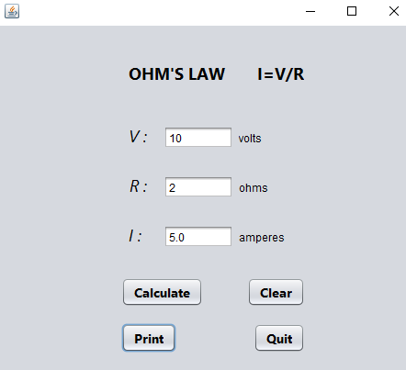

**Task # 02**

**Solution:**

private void gbtnActionPerformed(java.awt.event.ActionEvent evt) {

int t,c;

t=Integer.parseInt(tabletxt.getText());

for (int i = 1; i <= 10; i++) {

c=i*t;

ctable.append(t+" x "+i+" = "+c+"\n");

}

}

private void cbtnActionPerformed(java.awt.event.ActionEvent evt) {

tabletxt.setText(""); // TODO add your handling code here:

ctable.setText("");

}

**Output:**

